**JECRC – 45 Days In-campus Training (4 Semester)**

**Subject – Cloud , Devops & SRE**

**Topic – AWS, DOCKER, PORTAINER**

**MINI PROJECT 4**

**Title:** Accessing Container Portal (Portainer) with QR Code

**Introduction:**

In this mini-project, we will explore the process of running portainer through docker and then generating a QR Code for it such that one can access portainer’s portal using this QR Code.

**Objective:**

The main objective of this mini-project is to run or access portainer through a QR Code which is generated to access the portainer.

**Tools and Technologies:**

Amazon Web Services (AWS) account

Amazon Elastic Compute Cloud (EC2)

Docker

Docker Hub Image of Portainer

Portainer

**PROCEDURE:**

1. First we have to create a EC2 instance and then find the proper docker image of Portainer.

IMAGE: portainer/portainer-ce

You may use this image or any other image that you find suitable/appropriate.

1. Now access your EC2 instance and then run the following command:

* **docker run -d -p 8000:8000 -p 9443:9443 --name portainer --restart=always -v /var/run/docker.sock:/var/run/docker.sock -v portainer_data:/data portainer/portainer-ce:latest**

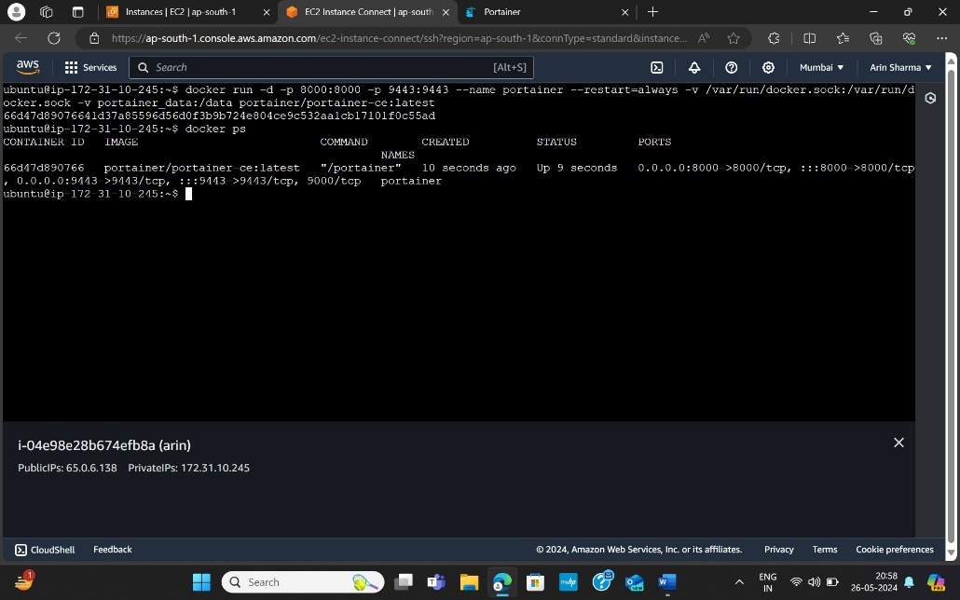

1. Now access your portainer by entering this address in your broser <https://yourIP:9443>

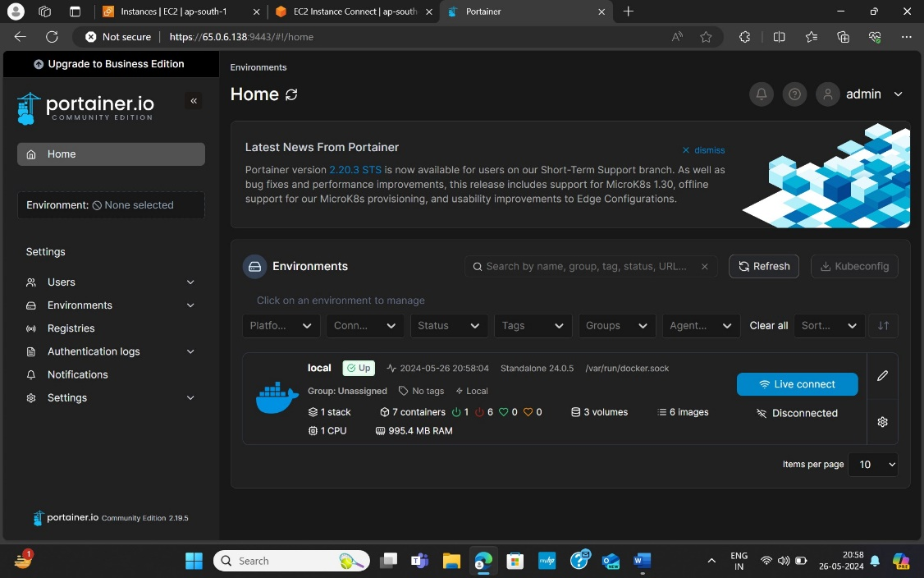

1. And go to any QR Code generator website and there paste your address and generate a QR Code and it will look something like this.



**CONCLUSION:**

In the end, we were able to generate a QR Code for our portainer which we deployed through our EC2 instance.